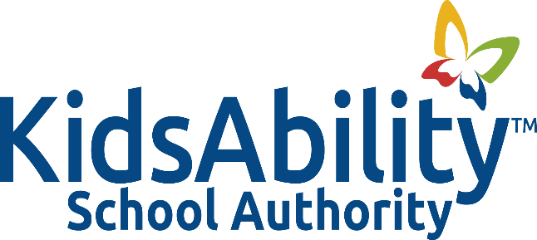

Title: TRUSTEE CODE OF CONDUCT
Adopted: October 2022
Reviewed:
Revised: March 2023, October 2023
Authority: Ontario Education Act Sec 209 (1)
Ontario Education Act Sec 218 (1) (2) (3)
Ontario Regulation 246/18
Municipal Freedom of Information and Protection of Privacy Act
Municipal Conflict of Interest Act

Related: Procedure 1001A: Trustee Code of Conduct

POLICY
- It is the policy of the KidsAbility School Authority that Trustees of the Authority shall discharge their duties loyally, faithfully, impartially and in a manner that will inspire public confidence in the abilities and integrity of the Authority

BACKGROUND
- A KidsAbility School Authority trustee applies to the KidsAbility School Authority Board and is appointed by the Minister of Education through the Public Appointments Secretariat.
- This Code of Conduct contributes to confidence in education and respect for the integrity of trustees in the community in that it deals with acceptable and respectful behaviours.

GUIDING PRINCIPLES
- Trustees are responsible for upholding the policies, commitments, strategic priorities and outcomes of the KidsAbility School Authority.

- A trustee appointment is a volunteer position. At the same time, it is important to recognize the public trust and responsibility the KidsAbility School Authority carries and that this trust and responsibility is honoured through determining and enforcing norms of acceptable behaviour.

- Trustees of the Authority shall recognize that the expenditure of school authority funds is a public trust and endeavour to see that the funds are expended efficiently, in the best interests of the students.

- Trustees shall be aware that as leaders of the Authority, they must uphold the dignity of the office and conduct themselves in a professional manner.
- Trustees shall ensure that their public comments are issue-based and not personal, demeaning or disparaging with regard to fellow trustees, stakeholders or the Authority as a whole.
- Trustees shall endeavour to participate in ongoing trustee professional development opportunities to enhance their ability to fulfill their obligations.

