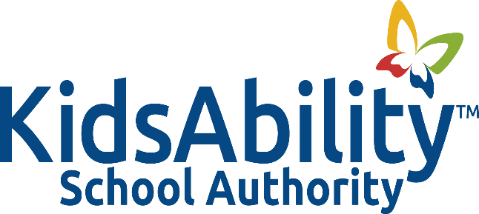

Title: STRATEGIC PLANNING

Adopted: February 2018
Reviewed:
Revised: October 2023
Authority: Ontario Education Act Sec 169.9 (1)
The Strategic Role and Multi Year Planning

POLICY
It is the policy of the KidAbility School Authority that the work of the Authority will be guided by the strategic plan.
BACKGROUND
- Generally speaking, strategic planning is an organizational activity that is used to:

- set priorities
- ensure equity of access and in outcomes
- focus energy and resources
- strengthen operations
- ensure that employees and other stakeholders are working toward common goals
- establish agreement around intended outcomes and processes for monitoring results
- assess and adjust the organization’s direction in response to a changing environment

- The Strategic Plan and its accompanying implementation and operations plans usually address:
- Equity, student achievement and well-being
- Ensuring a safe and inclusive school environment and promoting anti-bullying initiatives
- Effective stewardship of the Authority’s resources
- The delivery of effective and appropriate educational programs.

- More specifically, an effective Strategic Plan includes:
- A shared vision and mission
- Clear values and beliefs that will drive actions
- A small number of strategic priorities that will drive the organization
- Results or outcomes congruent with these priorities
- Respect for human rights and equity for staff and students
- Accountabilities and performance measures for tracking progress in equity of outcomes for students and staff
- Alignment of resources – a balance between strategies and budget
- Key success indicators
- Strategy for monitoring progress
- A framework for leadership and accountability
- Alignment of policy with strategic directions
- An effective communication strategy
- Provision for continuous capacity building throughout the Authority in order to obtain end results
GUIDELINES
- Trustees and staff members will participate in the creation of an organizational strategic plan at appropriate intervals (i.e., every three to five years).

- The process for the development of the strategic plan will be the responsibility of the Governance Committee and include:
- Consultation, input and approval from the Board of Trustees
- A review of the mission, vision, values of the KidsAbility School Authority
- Staff input
- a broad community consultation involving all stakeholders
- Review of appropriate legislation and regulations
- Other information and resources deemed to be of relevance
- the identification of strategic goals.

- Staff members will have work plans that are based upon the organizational strategic plan.

- The Board of Trustees will set its annual budget and current priorities based on the strategic plan.

- The current plan will be reviewed on a yearly basis.

RESOURCES

Ontario Education Act Sec 169.1 (1)

The Strategic Role and Multi Year Strategic Planning

