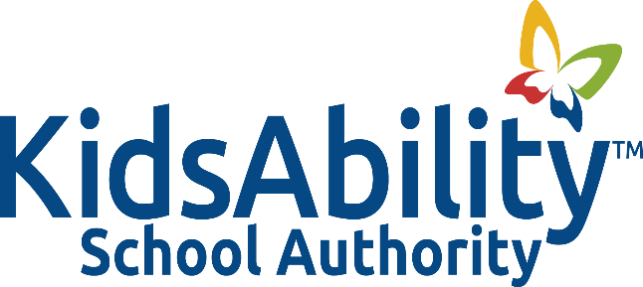

Title: MEMBERSHIP IN ONTARIO PUBLIC SCHOOL BOARDS’ ASSOCIATION

Adopted: October 2022
Reviewed:
Revised: October 2023
Authority: Ontario Education Act Sec 191.2 (3)

Related: Policy 1002: Governance

POLICY
It is the policy of the KidsAbility School Authority that the Authority commit to membership in the Ontario Public School Boards’ Association and that this membership commitment be reviewed annually.

BACKGROUND
- KidsAbility School Authority (KAS) recognizes the inherent values in maintaining a positive relationship with other public district school boards and school authorities throughout the Province of Ontario through membership in the Ontario Public School Boards’ Association.

GUIDELINES

- Membership in the Ontario Public School Boards’ Association (OPSBA) will be renewed annually in conjunction with the development of the School Authority’s operating budget. At that time, this policy will also be reviewed.

- In accordance with OPSBA’s bylaws, appointments to the following positions must be approved by trustees annually prior to the Annual General Meeting:
• Voting Delegate and Alternate for the OPSBA Annual General Meeting;
• Director and Alternate Director on the OPSBA Board of Directors.

- In conjunction with the above appointments, trustees may also nominate one of their members for the following positions:
• Executive Officers - President, First Vice-President, Second Vice-President (any
trustee from a member board is eligible for nomination);

• Regional Chair - Central West Region (any trustee from a member board in the
Central West Region is eligible for nomination);

• Regional Vice-Chair - Central West Region (any trustee who is appointed by a district
school board to the OPSBA Board of Directors is eligible for nomination);

• Regional Appointment to Core Issue Work Groups.

- Expenses incurred by trustees while attending OPSBA events will be reimbursed in accordance with the KidAbility School Authority Policy 1004: Trustee Roles and Responsibilities

RESOURCES

Ontario Education Act Sec 191.2 (3)

