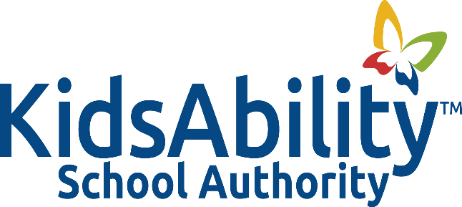

Title: EXPENDITURE GUIDELINES

Adopted: January 2015
Reviewed: June 2019
Revised: June 2017, October 2023
Authority: Ontario Education Act Sec 171 (1) 17: Powers of Boards
Broader Public Sector Expenses Directive
Ministry Memo 2006: B 15-School Board Expenditure Guidelines
Broader Public Sector Accountability Act, 2010

Related: Procedure 2002A: Expenditure Guidelines
Procedure 2002B: Emergency Needs Expenditure
Policy 2004: Procurement Cards
Procedure 2004A: Procurement Cards

POLICY
It is the policy of the Kidsability School Authority that employees and trustees be paid or reimbursed, in a manner which is transparent and in keeping with widely accepted best practices as well as the expectations of the Ontario government, for all reasonable out-of-pocket expenses incurred while performing duties on behalf of the Authority.

GUIDING PRINCIPLES

- The Authority will reimburse employees for travel, meals, accommodation expenses, other business expenses and hospitality expenditures incurred in carrying out their responsibilities while representing the interest of students, the school community or the Authority.

- Any expenses submitted for reimbursement must be fair and equitable, reasonable, appropriate, able to stand up to public scrutiny and properly explained and documented.

- The KidsAbility School Authority will pay or reimburse trustees and employees for legitimate expenses incurred in carrying out their responsibilities while representing the interests of students, the school community and/or the KidsAbility School Authority.

- All expenses to be reimbursed must be reasonable, relevant and transparent to the business activity of the Authority, with appropriate accountability and relate to the goals and objectives of the Authority’s strategic plan.

- For an expense to be paid or reimbursed it must have the appropriate authorizations and approvals as set out in the KidsAbility School Authority’s procedures for expenditures.

- The Authority assumes no obligation to reimburse expenses that do not comply with this policy.

DEFINITIONS
- Authorization: The approval of an expense reimbursement by an appropriate person with adequate signing authority.

- Receipts: Original documents that include details of the expenditure, the amount, taxes paid and the date. Credit card or debit receipts are NOT receipts.

RESOURCES

Ontario Education Act Sec 171(1) 17
Broader Public Sector Expenses Directive
School Board Expenses Guidelines
Broader Public Sector Accountability Act

