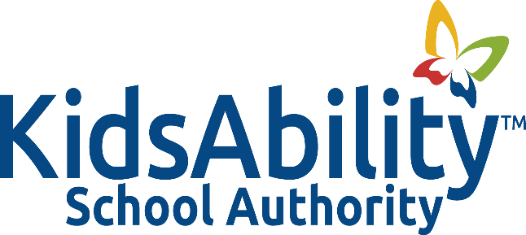

Title: REQUEST AND USE OF FOUNDATION DONATION MONEY

Adopted: November 2015
Reviewed:
Revised: October 2023
Authority:
Related: Policy 2002: Expenditure Guidelines
Procedure 2002A: Expenditure Guidelines

POLICY
It is the policy of the Kidsability School Authority that funds donated to the Authority may be accessed to cover unexpected expenses to acquire goods or services which would benefit the students at the school but which are not covered by Ministry of Education grants.

BACKGROUND
- The Ministry of Education funds school needs, based on an estimated budget submitted by the Authority to the Ministry prior to the school year.

- There are times when unexpected expenses or expenses arise that do not form part of the Ministry of Education mandate but would benefit the students at KidsAbility School. As a result, there are circumstances in which KidsAbility School Authority has to seek alternative funding which includes KidsAbility Foundation and the community.
PROCEDURES
- All donations designated to the KidsAbility School Authority are to be directed to and collected by the KidsAbility Foundation.

- KidsAbility School Authority Board approval is required prior to requesting donations and prior to the expenditure of the donated funds of over $1000 from the KidsAbility Foundation.

- Requests for funding by KidsAbility Foundation may be made only by the Principal or Board Chair.

- Receipts for donations, where applicable, are to be issued by the KidsAbility Foundation in accordance with its own policies and procedures guidelines.

- Any monies donated for the benefit of KidsAbility School Authority shall be acknowledged by the KidsAbility School Authority Board.

