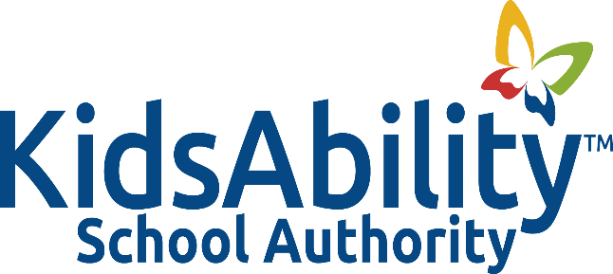

Title: SAFE SCHOOLS

Adopted: March 2015
Reviewed:
Revised: October 2023

Related: Policy 3006 – Safe Schools

PURPOSE
The purpose of this procedure is to provide guidelines and expectations pertaining to the duties of principals and teachers regarding the maintenance of safety, security and order in the school environment.

GUIDELINES
- To meet the goal of creating a safe, caring, and accepting school environment, the KidsAbility School Authority supports the use of positive practices as well as consequences for inappropriate behaviour, including progressive discipline, which includes suspension and expulsion where necessary.

- The KidsAbility School Authority supports the use of positive practices to prevent such behaviour and authorizes the Principal, having given due consideration to any mitigating circumstances, to impose consequences in appropriate circumstances, up to and including a referral to the Discipline Committee of the KidsAbility School Authority.

- The KidsAbility School Authority supports the use of disciplinary practices that are positive and inclusive in nature (e.g., restorative justice, counseling).

- The KidsAbility School Authority will implement proactive positive practices and corrective supportive practices when necessary. However, before applying disciplinary measures, the Principal or designate and Discipline Committee of the KidsAbility School Authority shall consider the discriminatory impacts of disciplinary decisions on pupils protected by the Human Rights Code, including but not limited to race and disability, and whether or not accommodation is required.
BACKGROUND
- Progressive discipline - The goal of these procedures, with respect to progressive discipline, is to support a safe learning and teaching environment in which every pupil can reach the pupil’s full potential. It should be noted that all students at the KidsAbility School should be considered as experiencing mitigating circumstances.

- Progressive discipline is a whole-school approach that utilizes a continuum of prevention programs, interventions, supports, and consequences to address inappropriate student behaviour and to build upon strategies that promote and foster positive behaviours. When inappropriate behaviour occurs, disciplinary measures should be applied within a framework that shifts the focus from one that is solely punitive to one that is both corrective and supportive. Schools should utilize a range of interventions, supports, and consequences that are developmentally and socio-emotionally appropriate and include learning opportunities for reinforcing positive behaviour while helping students to make better choices.” (PPM 145).

PROCEDURES

- The KidsAbility School Authority staff promote and support appropriate and positive pupil behaviours that contribute to creating and sustaining safe, comforting and accepting learning and teaching environments which encourage and support students to reach their full potential. The KidsAbility School Authority supports the use of positive practices for: (1) prevention and (2) positive behaviour management.

- The KidsAbility School Authority also encourages the review and amendment, as appropriate as per Individual Education Plans, Behaviour Management Plans and Safety Plans, at regular intervals and following an incident to ensure that every student with disability-related needs is receiving appropriate accommodation up to the point of undue hardship.

- Preventative practices may include:
- self-advocacy programs;
- Human Rights strategy pursuant to PPM 119;
- anti-bullying and violence prevention programs;
- mentorship programs;
- character education;
- citizenship development including global outreach;
- promotion of healthy student relationships;
- healthy lifestyles

- Positive behaviour management practices include:

- program modifications or accommodations;
- class placement;
- positive encouragement and reinforcement;
- conflict resolution/dispute resolution;
- promotion of healthy student relationships;
- sensitivity programs;
- integrating mindful breathing techniques;
- observing visual signals of mood;
- planned breaks;
- safety Plans (including input from the Rehab. Team)
- referral to child/youth worker or social worker through the centre;
- consultation with appropriate resource team
- student success strategies.

- The KidsAbility School Authority recognizes that, in rare circumstances, positive practices might not be effective or sufficient to address inappropriate pupil behaviour. In such circumstances, the KidsAbility School Authority supports the use of consequences.

- It is the expectation of the KidsAbility School Authority that, provided there is no immediate risk of physical harm to any individual, all staff members (including administrators, teachers, educational assistants, therapists, social workers, child and youth workers, psychologists, and speech and language pathologists) who work directly with pupils on a regular basis, shall respond to inappropriate and disrespectful behaviour or any other behaviour that causes a negative school climate or for which a suspension or expulsion may be imposed, which they have observed or heard during the course of their duties or otherwise while on school property or during a school related event.

- In the event that there is perceived immediate risk of physical harm, the employee has an obligation to report to the Principal in writing (i.e., fill out an incident report form). If necessary, a meeting will be convened to discuss the matter further. In all cases, the Principal will acknowledge receipt of the written report. The written report should include a description of the incident including the location, student(s) involved, date and time.

- The Principal must consider all mitigating and other factors, as required by the Education Act, set out in Ontario Regulation 472/07 and reflected in student discipline settlements with the Human Rights Commission.

- In circumstances where a pupil will receive a consequence for the pupil’s behaviour, it is the expectation of the KidsAbility School Authority that the principle of progressive discipline, consistent with the Human Rights Code, Ministry of Education direction and PPM 145, will be applied, if appropriate.

- Progressive discipline may include early and/or ongoing intervention and support strategies, such as:

- contact with the pupil’s parent(s)/guardian(s);
- oral reminders;
- review of expectations;
- referral to a Social Worker
- change arrangement of seating in the classroom;
- conflict mediation and resolution; and/or
- consultation with appropriate resource team

- If the ideas suggested in #16 are not successful, progressive discipline may also include a range of interventions, supports and consequences. When inappropriate behaviours continue to occur, strategies such as the following (with a focus on improving behaviour) may be included:

    - meeting with the pupil’s parent(s)/guardian(s), pupil and Principal;
    - withdrawal of privileges
    - behaviour contracts;
    - a verbal apology, if appropriate;
    - restitution for damages; and/or
    - development of a safety plan.

- Progressive discipline is most effective when dialogue between the school and home regarding student achievement, behaviour and expectations is open, courteous and focused on student success.

- When addressing inappropriate behaviour, school staff should consider the particular pupil and circumstances, including any mitigating and other factors as set out in the student discipline procedures, the nature and severity of the behaviour, and the impact on the school climate.

