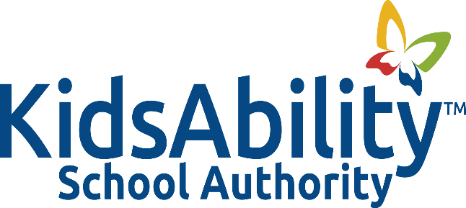

Title: STAFF SERVICE AND RETIREMENT RECOGNITION

Adopted: December 2018
Reviewed:
Revised: November 2022, October 2023
Authority:

POLICY
It is the policy of the KidsAbility School Authority to recognize staff years of service and on the occasion of their retirement.

GUIDELINES
- Every five years, starting at 5 years of service, staff will receive, a hand written card from the Board, and an amount to reflect the number of years of service. Service awards will be presented by Board personnel in a public forum with their peers present.

Years of Service Board Contribution
5 $40.00
10 $50.00
15 $75.00
20 $100.00
25 $125.00
30 $150.00
35 $175.00
40 $200.00

- Upon retirement a staff member will receive the following:
Years of service Authority Contribution
1-5 $50.00
6-10 $100.00
11-14 $125.00
15-19 $150.00
20-23 $200.00
24 and above $250.00

- Retirement gifts will be presented by Authority personnel in a public forum with their peers present

