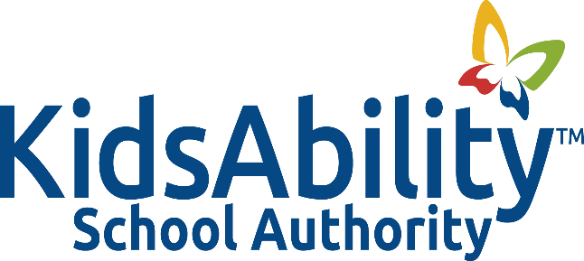

Title: COVID 19 VACCINATION

Adopted: September 2021
Reviewed:
Revised: October 2023
Authority: Instructions Issued by the Office of the Chief Medical Officer of Health
KidsAbility Centre Covid 19 Vaccination Policy

POLICY
It is the policy of the Kidsability School Authority that all Authority covered individuals (as defined in guiding principle #5 below) must be fully vaccinated or have an approved medical or Human Rights exemption.

BACKGROUND
- COVID-19 is an acute respiratory illness caused by the severe acute respiratory syndrome coronavirus 2 (SARS-CoV-2). It may be characterized by fever, cough, shortness of breath, and several other symptoms. Asymptomatic infection is also possible. The risk of severe disease increases with age but is not limited to the elderly and is elevated in those with underlying medical conditions.

- The CMOH has directed KidsAbility School Authority to develop, implement and ensure compliance with a COVID-19 immunization disclosure policy.

- An educational program has been prescribed by the Ministry of Education and addresses the following learning components:
- How COVID-19 vaccines work;
- Vaccine safety related to the development of the COVID-19 vaccines;
- Benefits of vaccination against COVID-19;
- Risks of not being vaccinated against COVID-19; and
- Possible side effects of COVID-19 vaccination.
GUIDING PRINCIPLE
- The KidsAbility School Authority recognizes the importance of immunization as a key element to help keep school settings safe. This policy regarding COVID-19 vaccination, immunization and disclosure aims to protect the Authority’s population of vulnerable children who may not be eligible for vaccination due to age and medical conditions and who are mostly exempt from wearing face masks and/or shields.

- This policy regarding vaccination, immunization and disclosure applies to the following groups (“covered individuals”):

- All school authority employees/staff, including daily and long-term occasional teachers and casual education workers;
- School authority trustees;
- Students on educational placement, including professional services students on a placement/work-integrated learning visit (e.g., teacher candidate practicums, nurse, therapists, etc.);
- Volunteers;
- Frequent visitors, including third-party contractors.

GUIDELINES

- For the purpose of this Policy, “full vaccination” means having received at least two doses of a COVID-19 vaccine or combination of COVID-19 vaccines approved by the World Health Organization and having received the final dose of the COVID-19 vaccine at least 14 days ago.

- The Kidsability School Authority will follow the policies and protocols of the Kidsability Centre as they pertain to vaccination and masking. As circumstances change, the Authority’s protocols will be altered to be consistent with those of the centre.

PROCEDURES

- The purpose of these procedures is to outline KidsAbility School Authority’s expectations with regards to COVID-19 immunization and disclosure for staff, volunteers, third-party contractors, student practitioners, frequent visitors and other professionals who provide in-person services in schools and who have direct contact with staff and/or students (“the covered individuals”).

- All individuals covered by this policy must provide one of the following:
- Proof of all required doses of a COVID-19 vaccine approved by the world Health Organization
- Written proof of a medical reason, provided by either a physician or nurse practitioner that sets out:
- That the person cannot by vaccinated against COVID-19; and
- The effective time period for the medical reason (i.e., permanent or time-limited)
- Proof that the individual has completed the educational program prescribed by the Ministry of Education.

- Those individuals who are exempt from vaccination for medical or due to their creed must complete daily rapid antigen testing for COVID-19 and demonstrate a negative result for each day in attendance at KidsAbility School. Individuals must provide verification of the negative test result via text or email to the school office prior to school arrival each day.

- Daily proof of a negative test continues to be a requirement of attending KidsAbility School for 14 days after receiving a second dose.

- Individual rapid antigen test kits will be provided to those individuals needing to fulfill the testing requirement. Tests will be completed off-site during non-work time.

- Staff members hired must be fully vaccinated or have an exemption prior to assuming their duties as per the policies and protocols of the centre.

- The requirements of this Policy are in addition to existing infection control measures that have been or may be implemented. In accordance with Public Health requirements, all workers and visitors are required to comply with all infection control measures, including physical distancing, hand hygiene, screening for symptoms of COVID and wearing appropriate PPE and while in attendance at KidsAbility sites.

- The KidsAbility School Authority is required pursuant to the Chief Medical Officer of Health’s direction, to report statistical information to the Ministry of Education. All statistical information will be provided in depersonalized aggregate form on a monthly basis.

